**Test Document for Open Entries from Purchase Order Invoice Processing for index2**

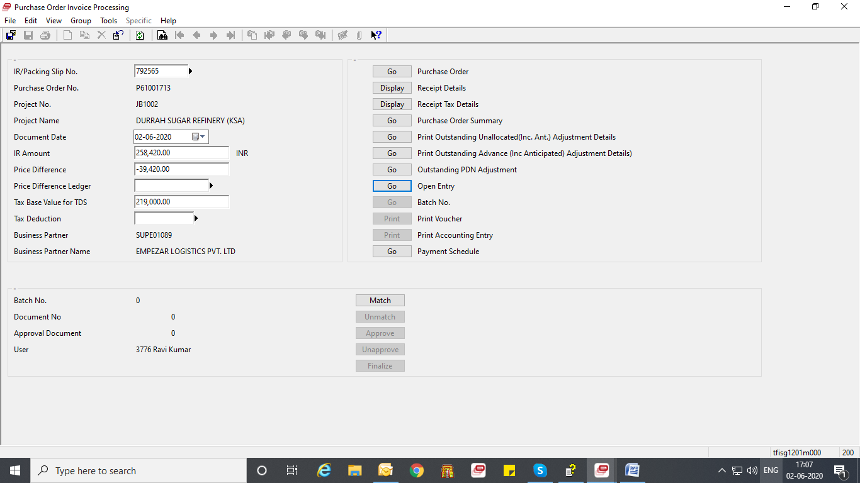

Results:

